Salesforce Administrator Self-Learning & Super Badges

SALESFORCE ADMINISTRATOR - SELF LEARNING

Process Automation

Automate Your Business Processes with Salesforce Flow

Sub heading :- Salesforce Flow

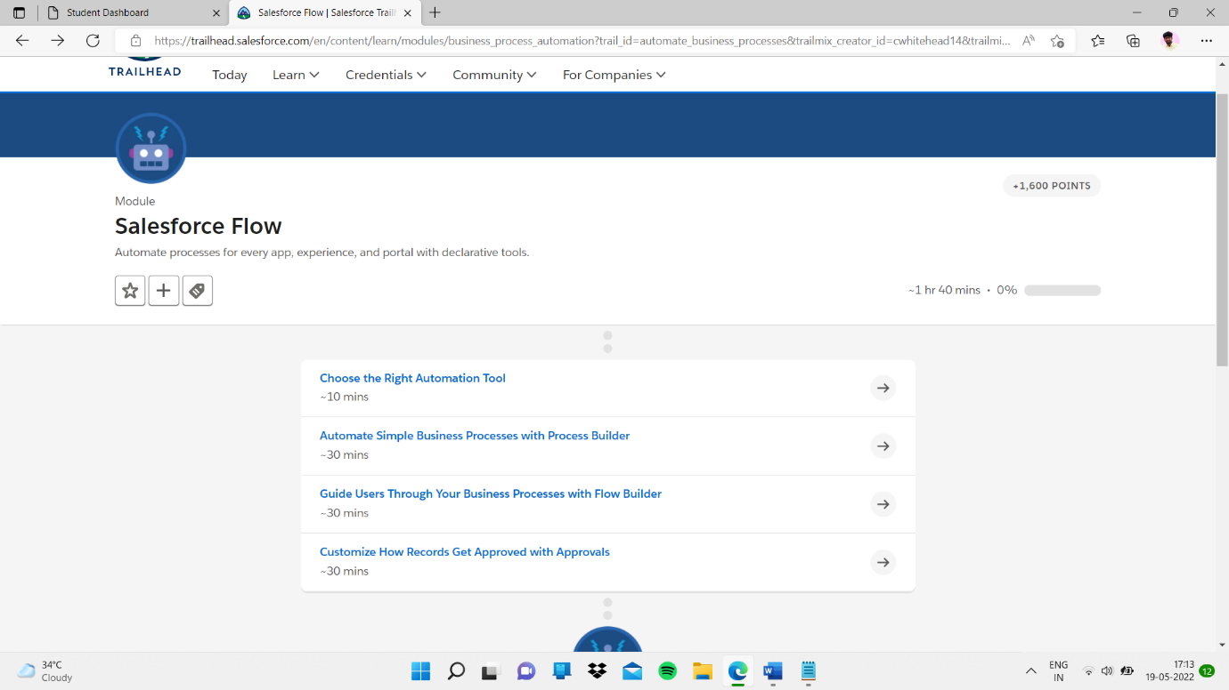

Sub topic :- Choose the Right Automation Tool

Quiz had completed

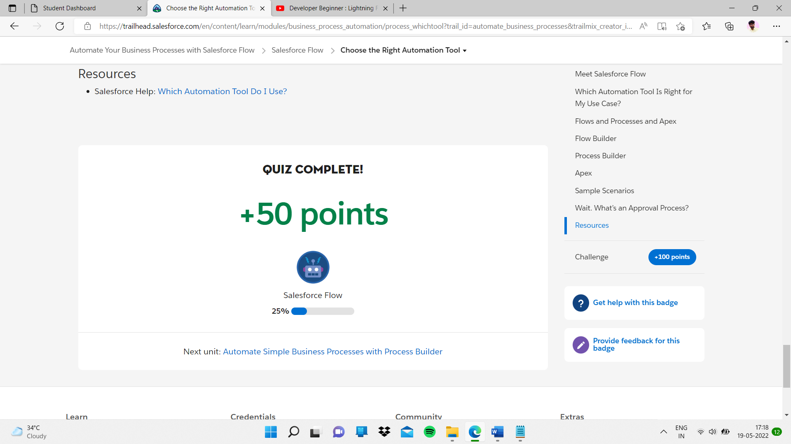

Sub topic:- Automate Simple Business Processes with Process Builder

My task

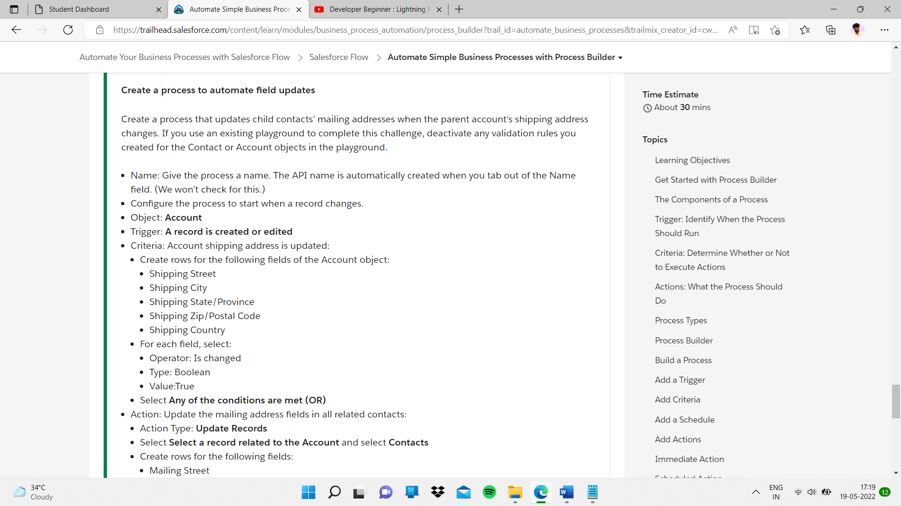

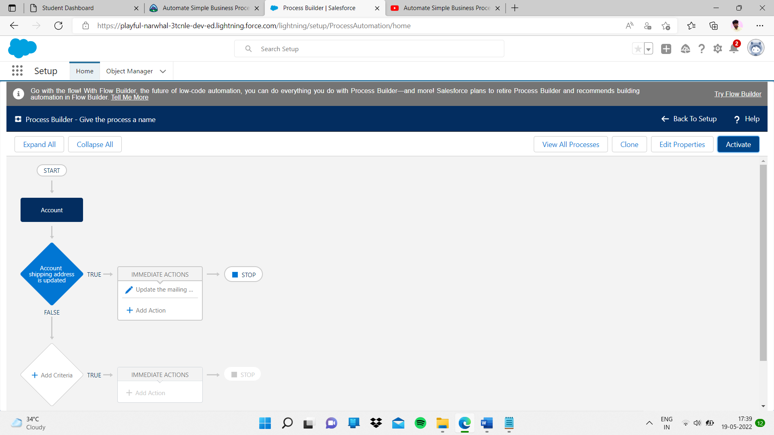This like I applied all things on that and I completed task

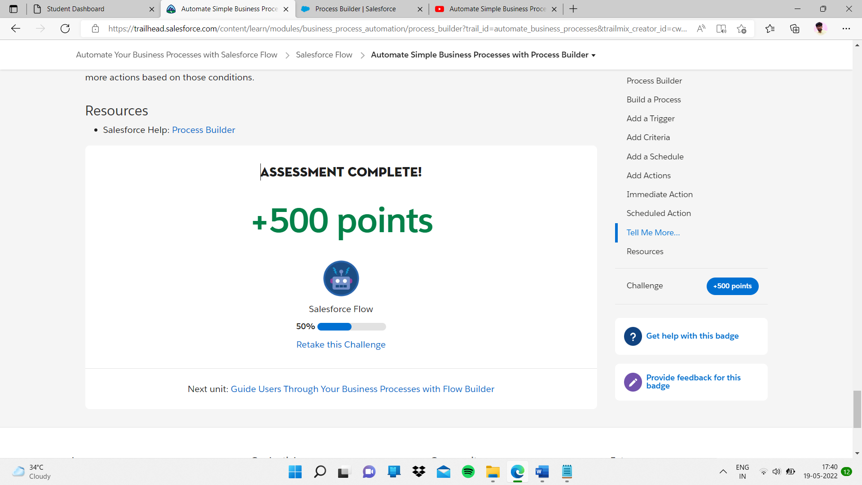

Sub topic:- Guide Users Through Your Business Processes with Flow Builder

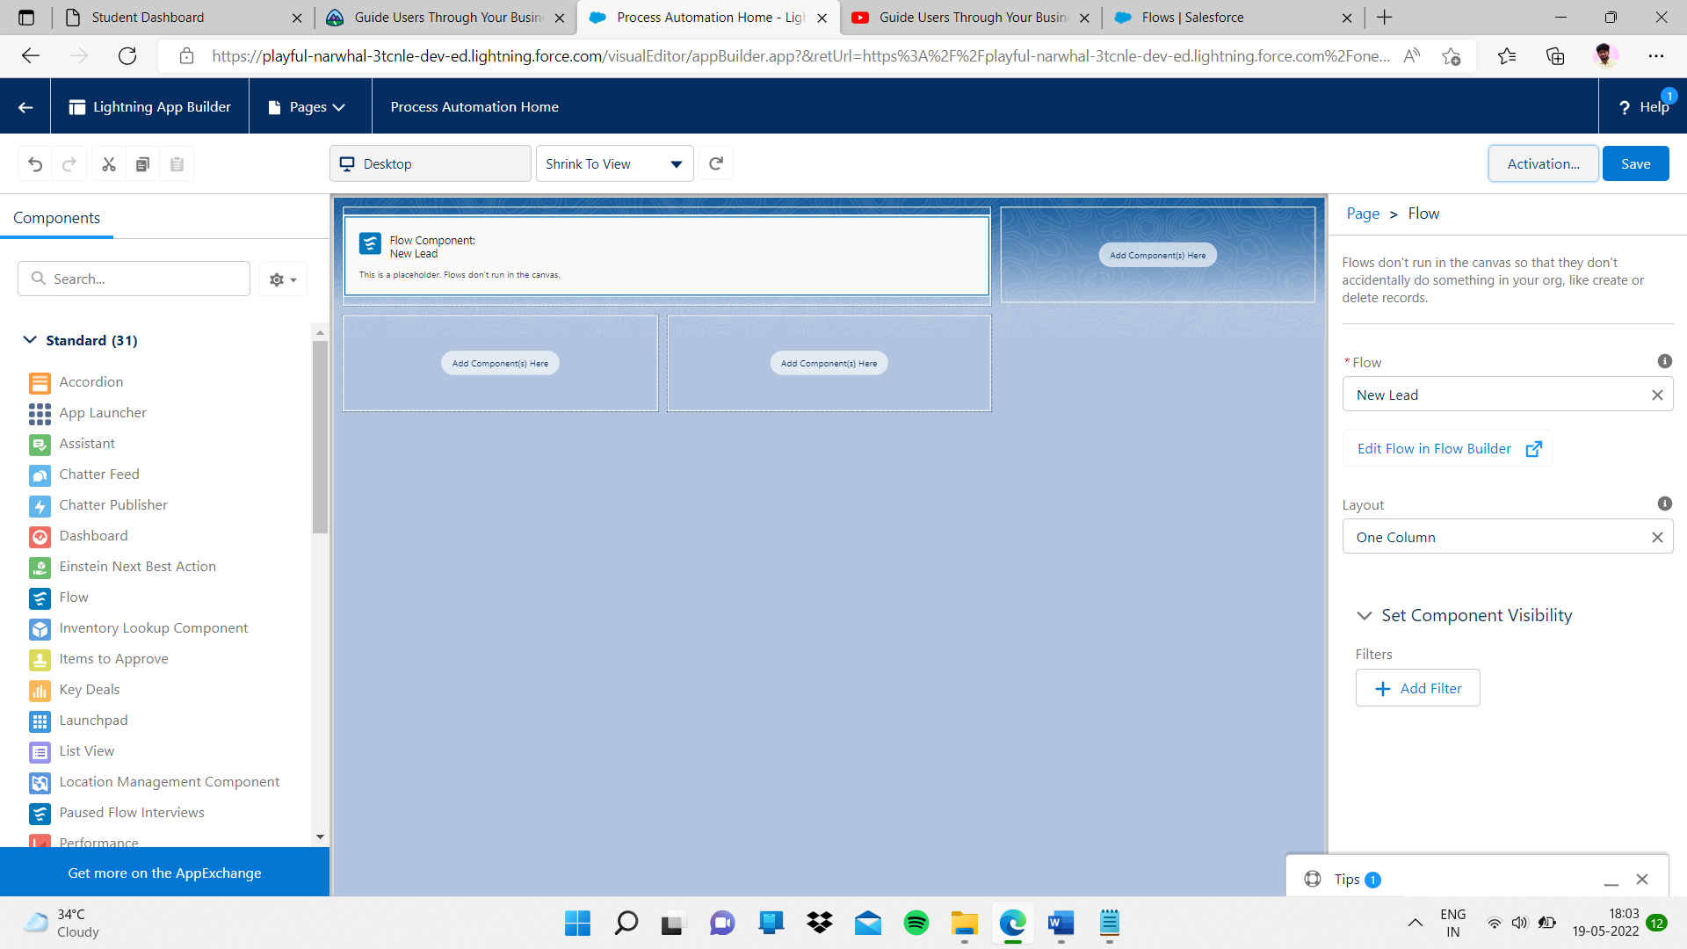

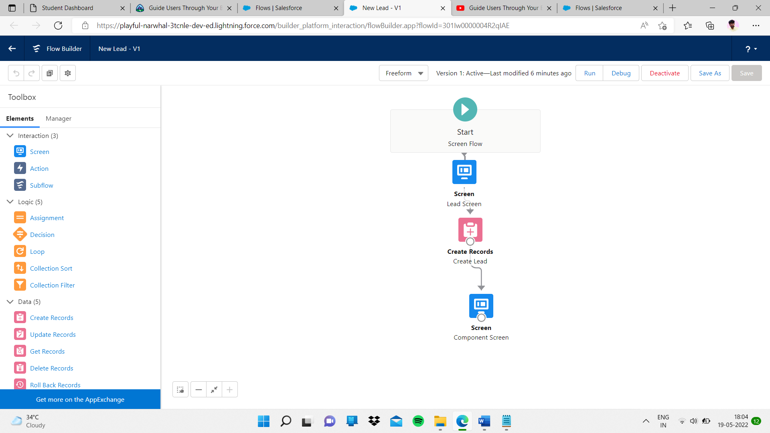

Final completed task

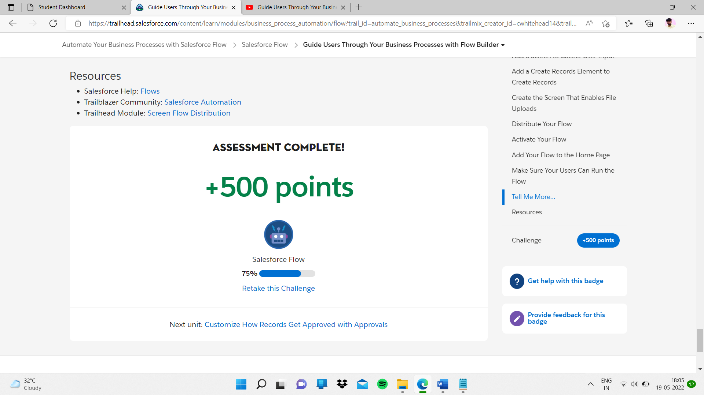

Sub topic:- Customize How Records Get Approved with Approvals

My task:-

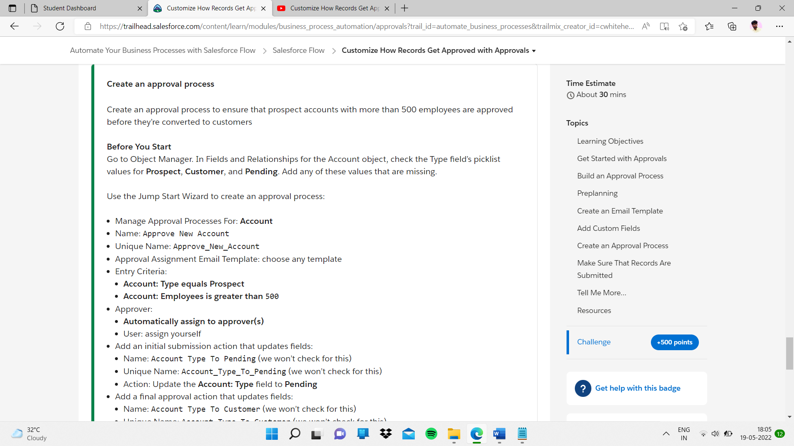

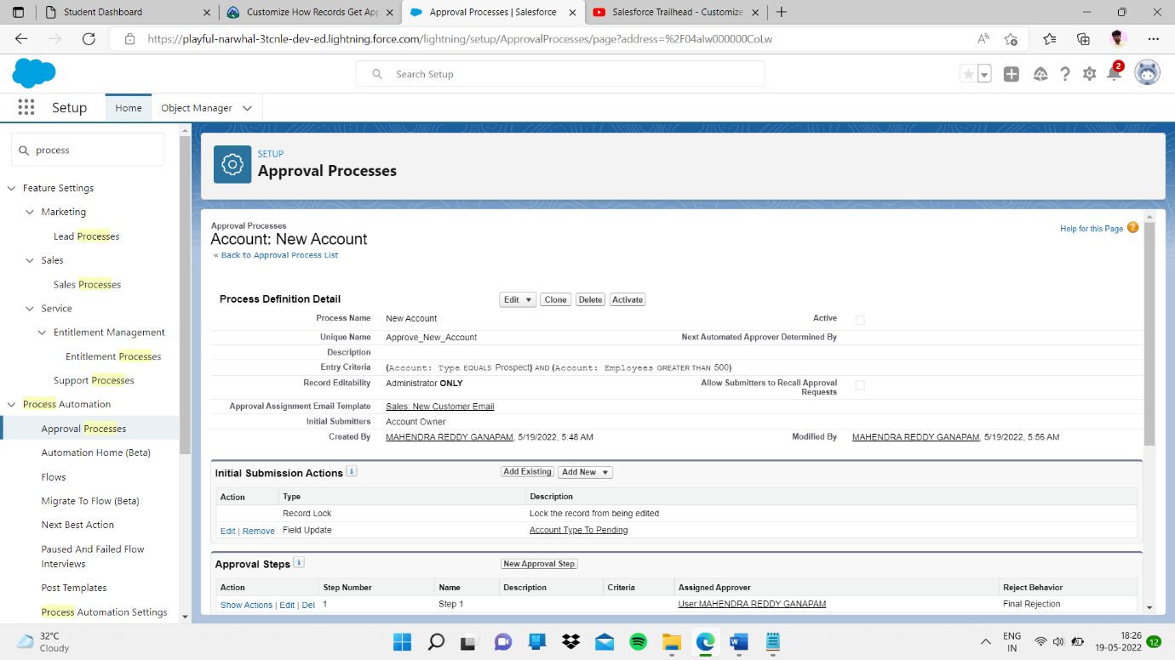

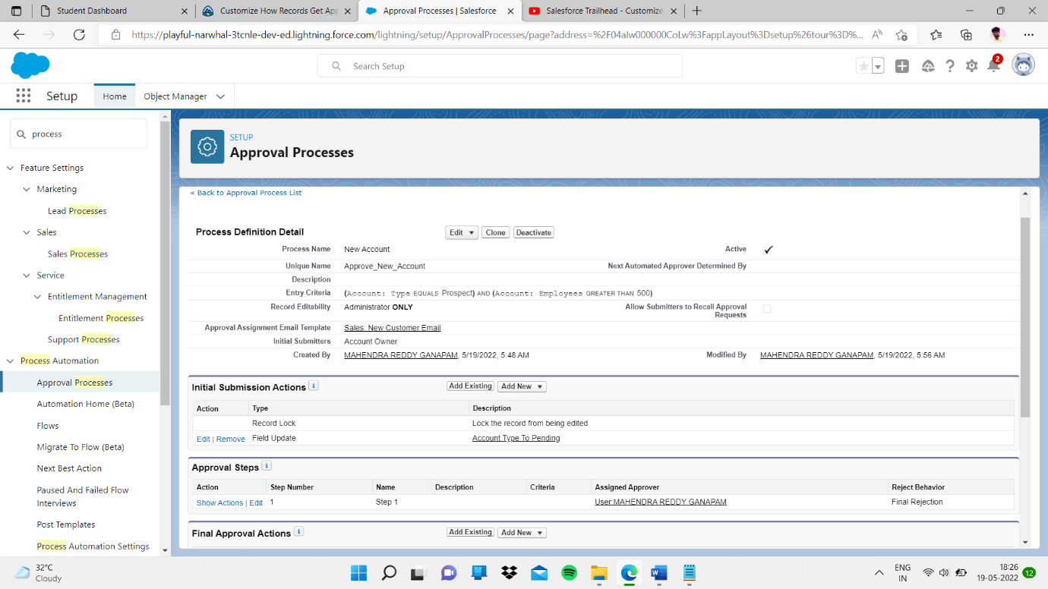

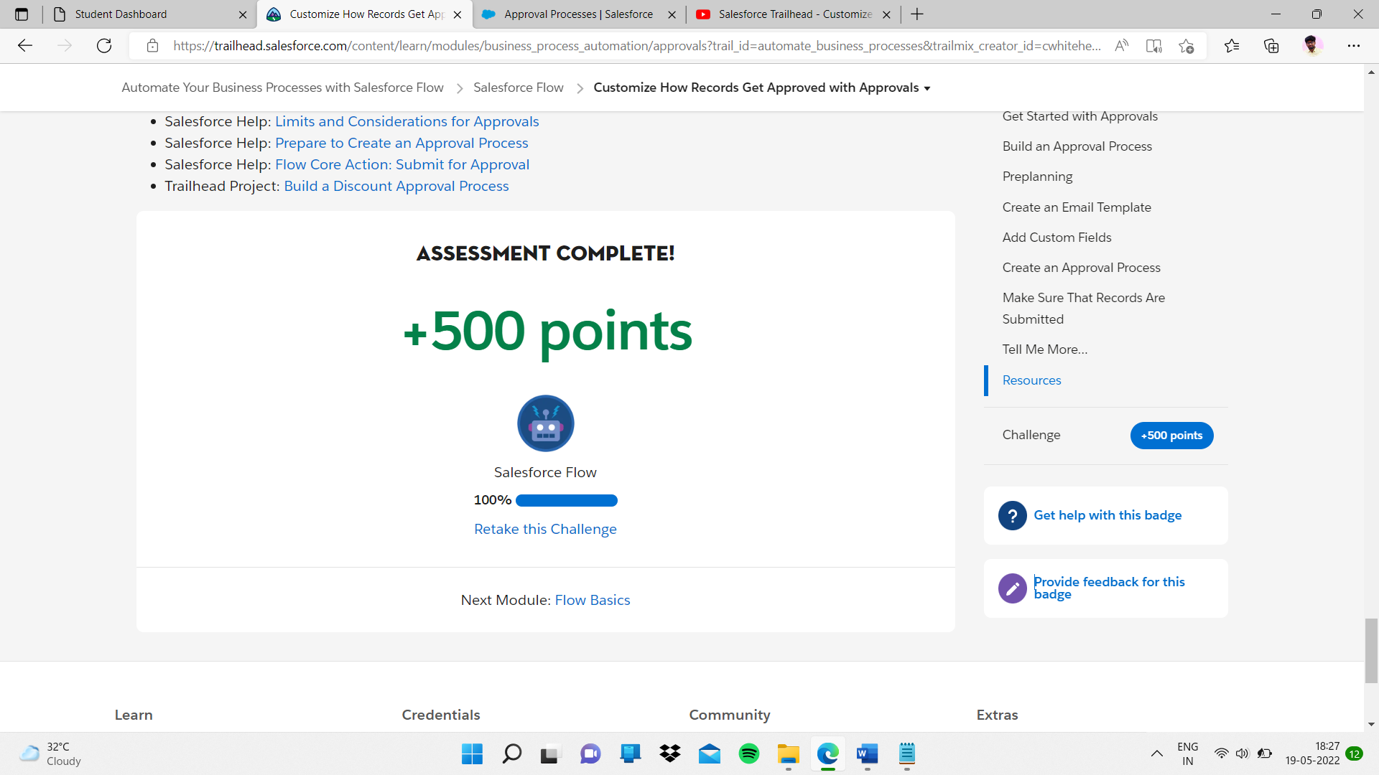

Sub heading:- Flow Basics

Sub topic:- Get Started With Flows

I completed quiz

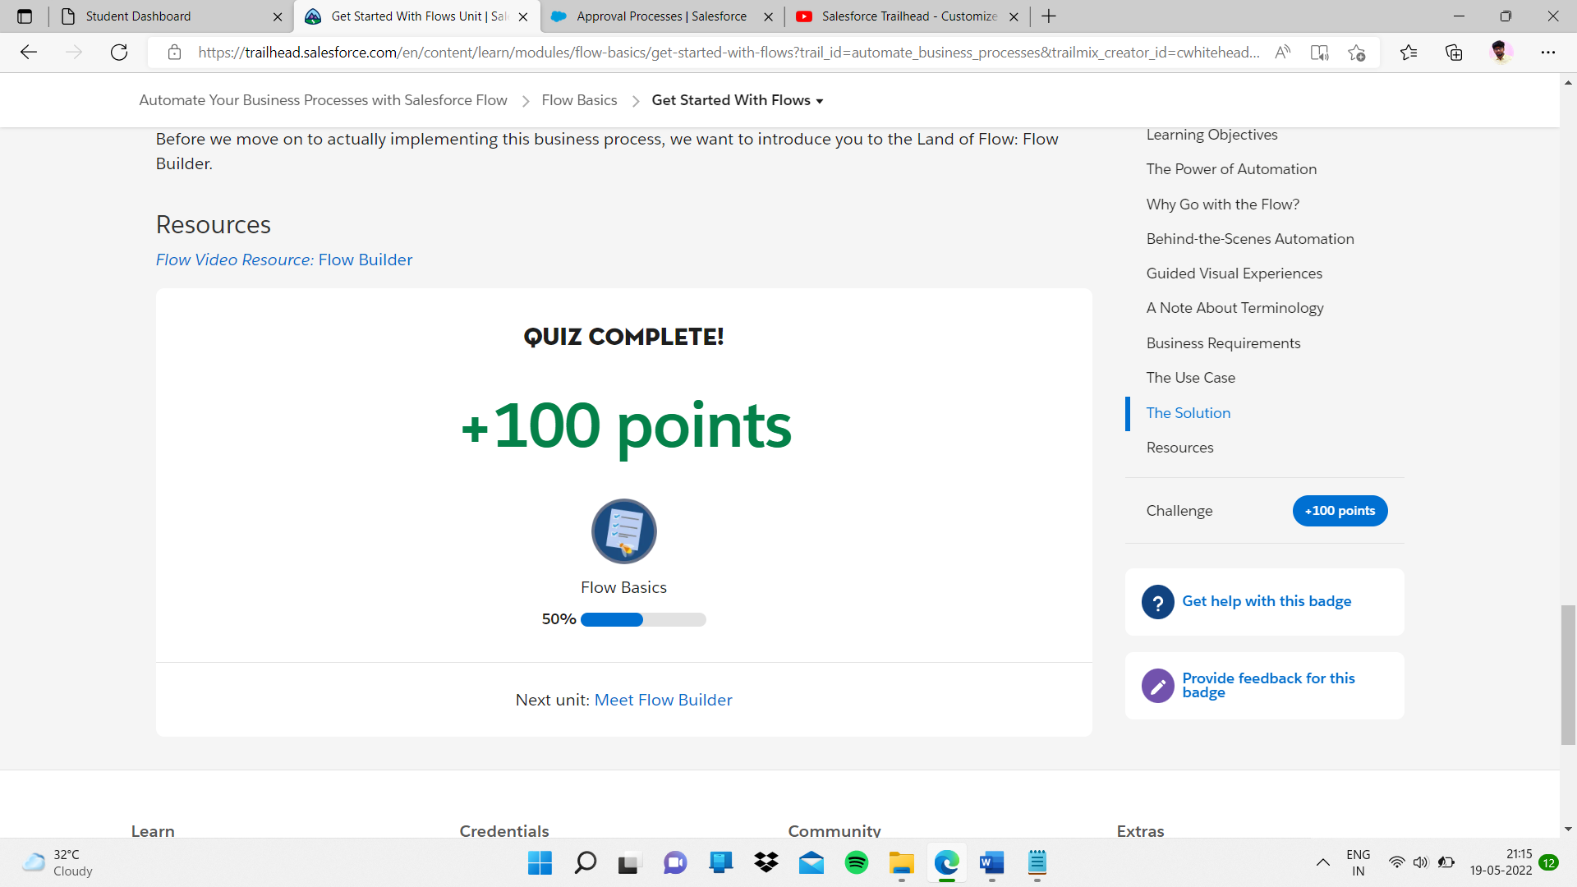

Sub topic:- Meet Flow Builder

In this I completed quiz

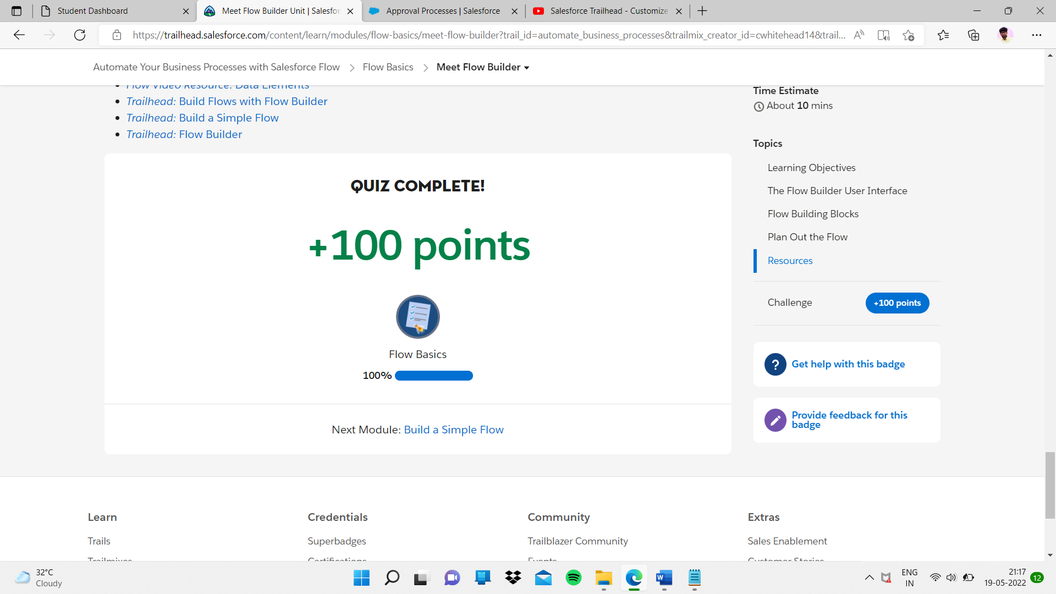

Sub heading:- Get Started With Flows

Sub topic:- Collect Contact Info from Your User

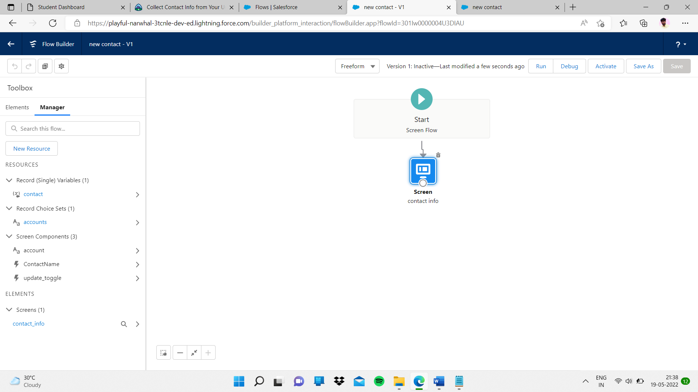

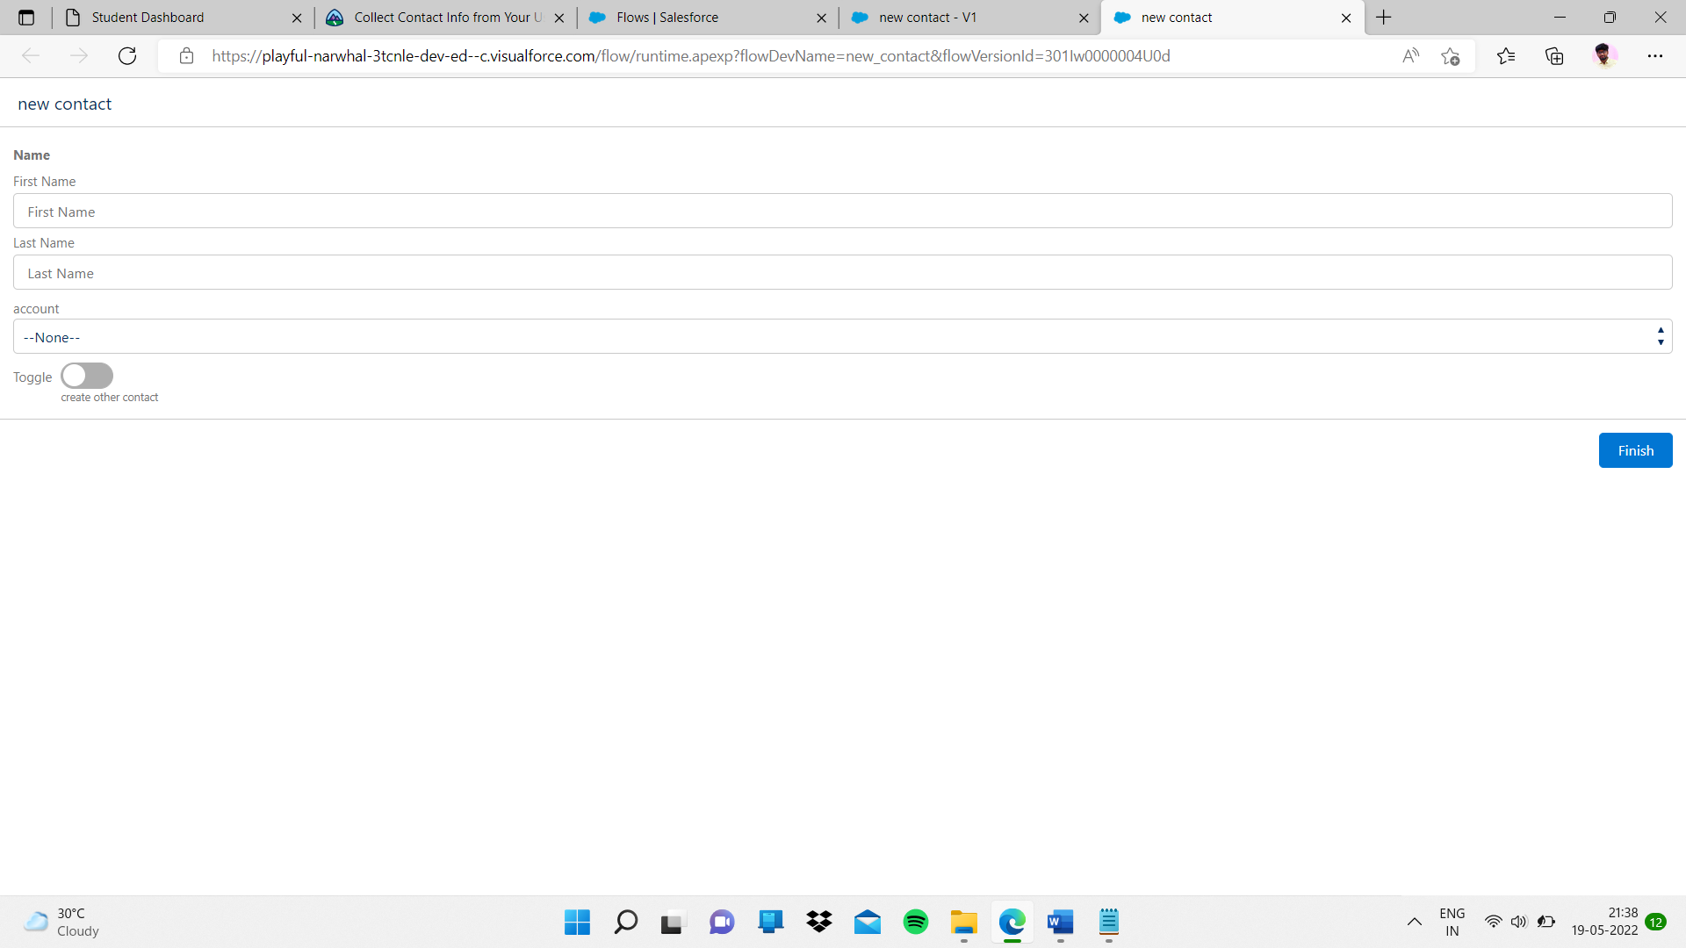

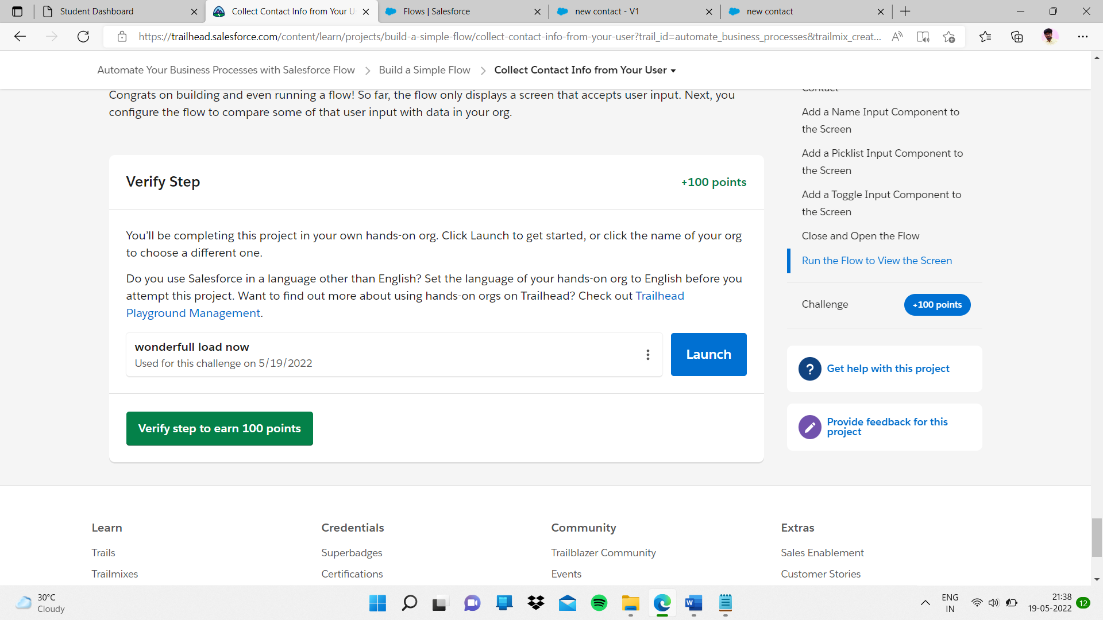

Given task completed

# Sub topic:- **Check for a Matching Contact in Your Org**

My task

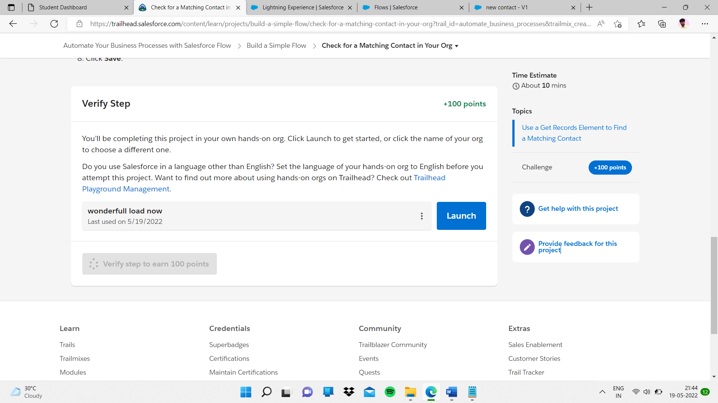

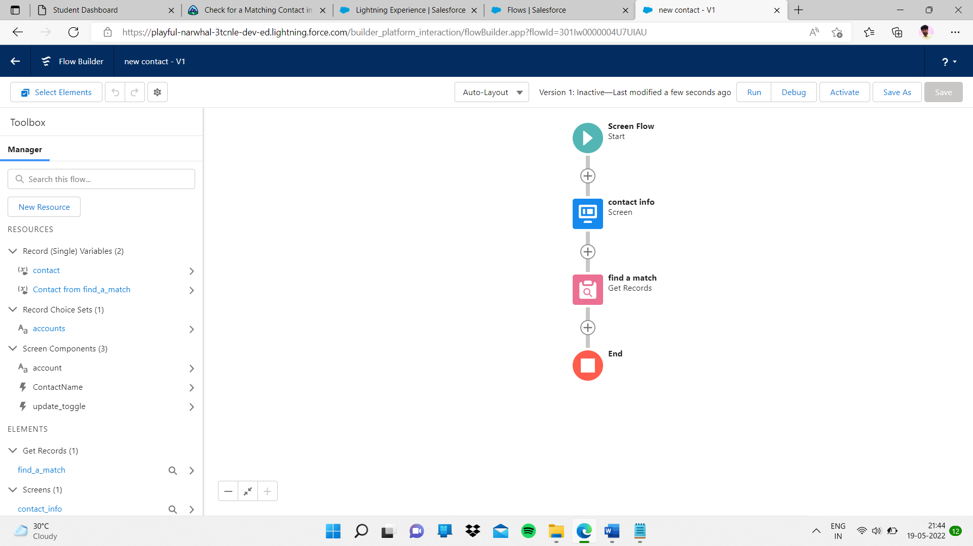

Completed task

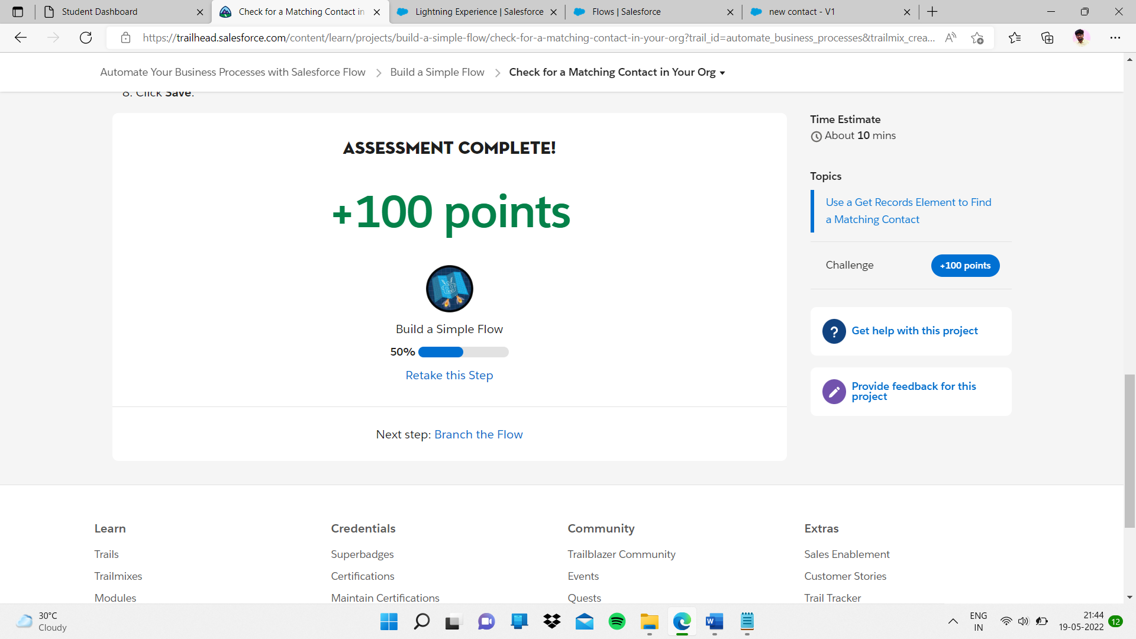

Sub topic:- Branch the Flow

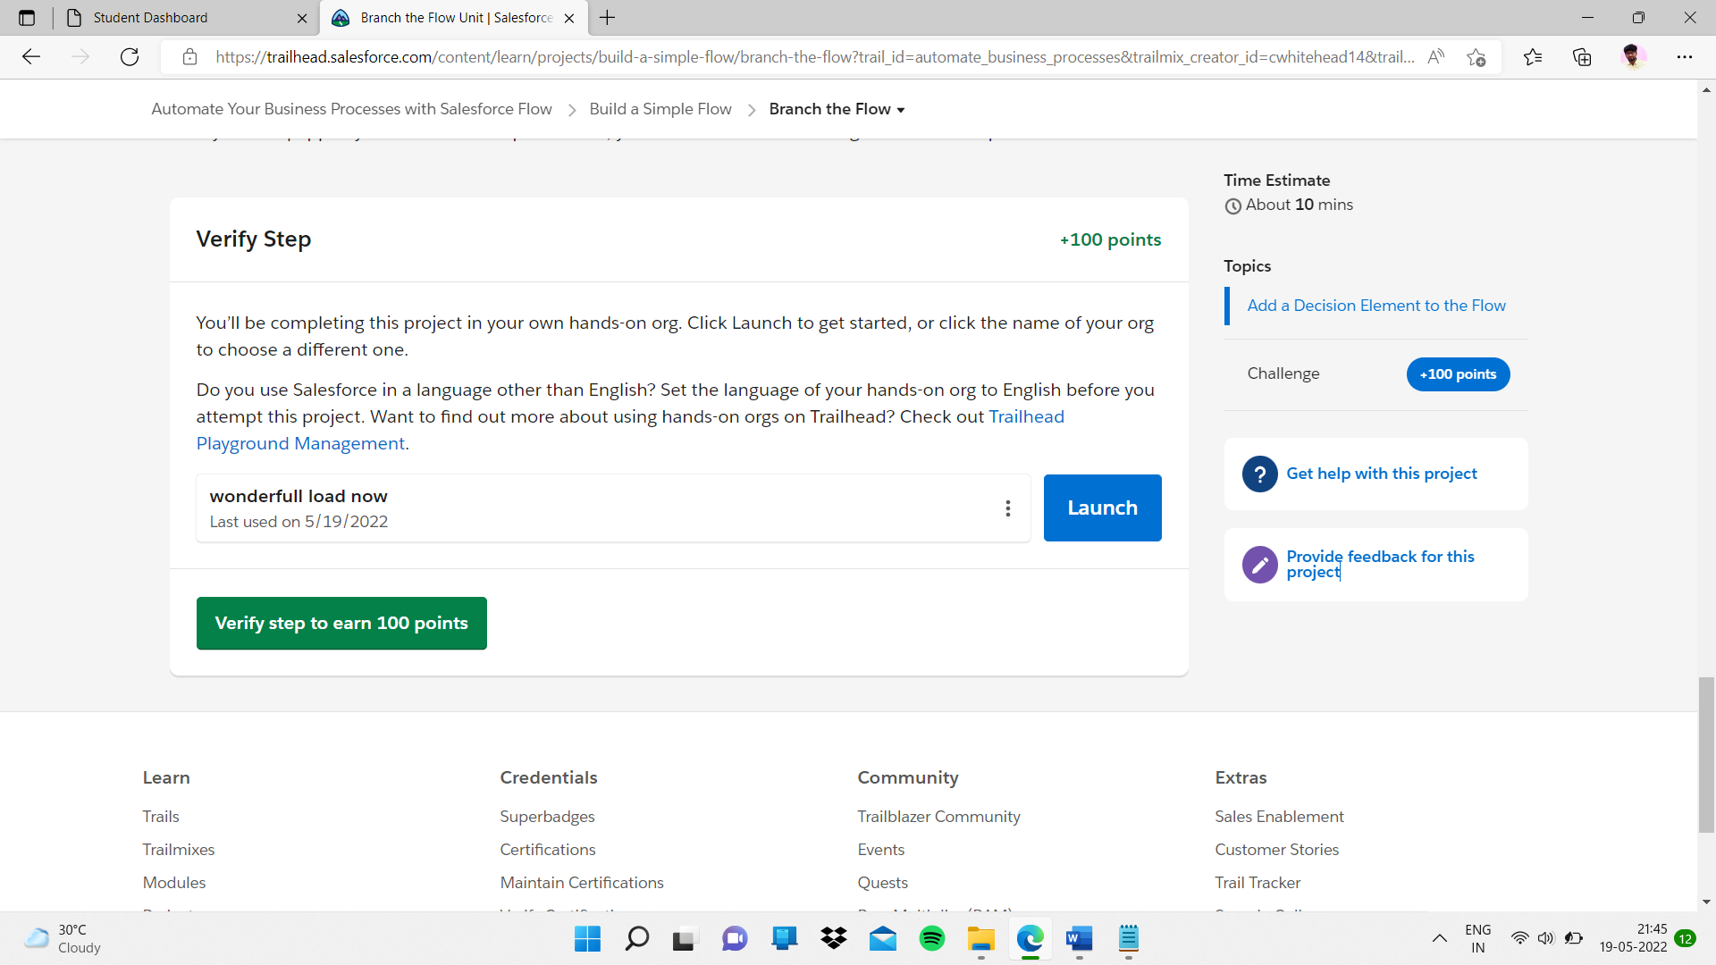

Given task

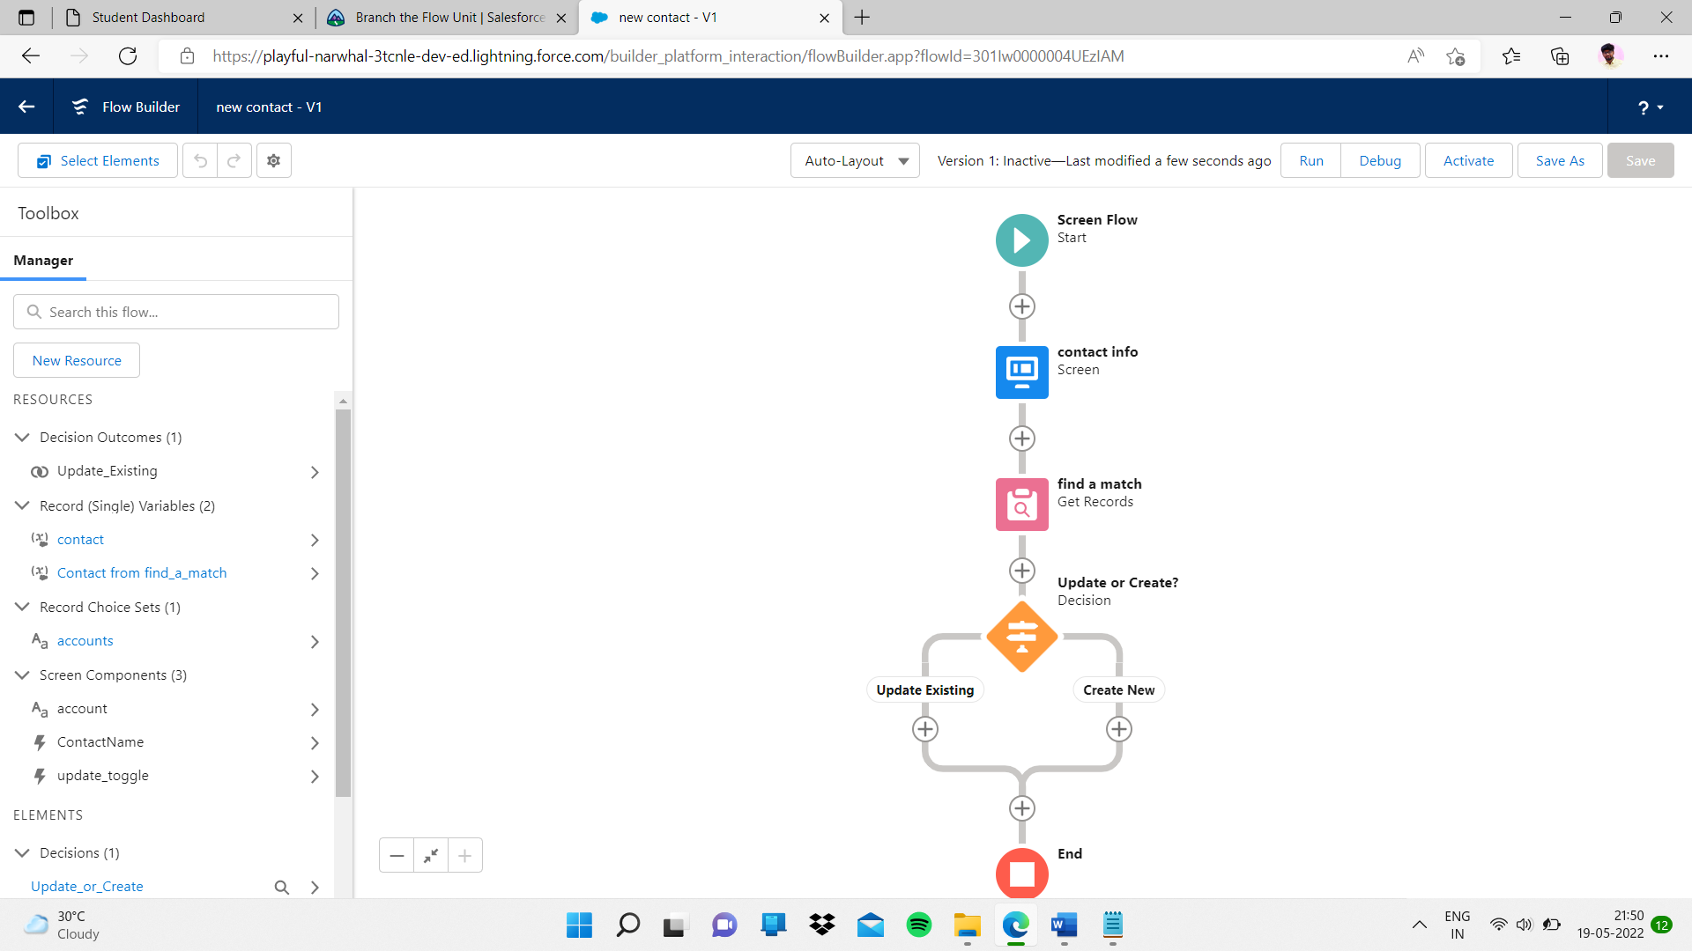

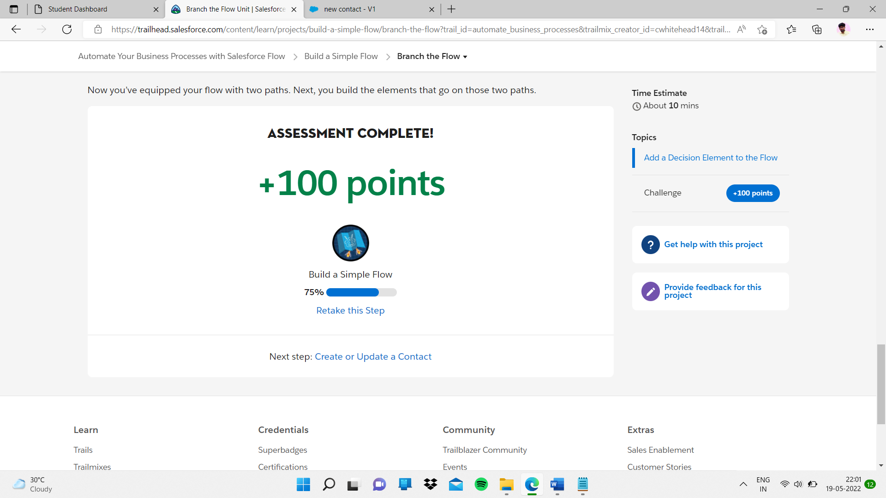

Sub topic:- Create or Update a Contact

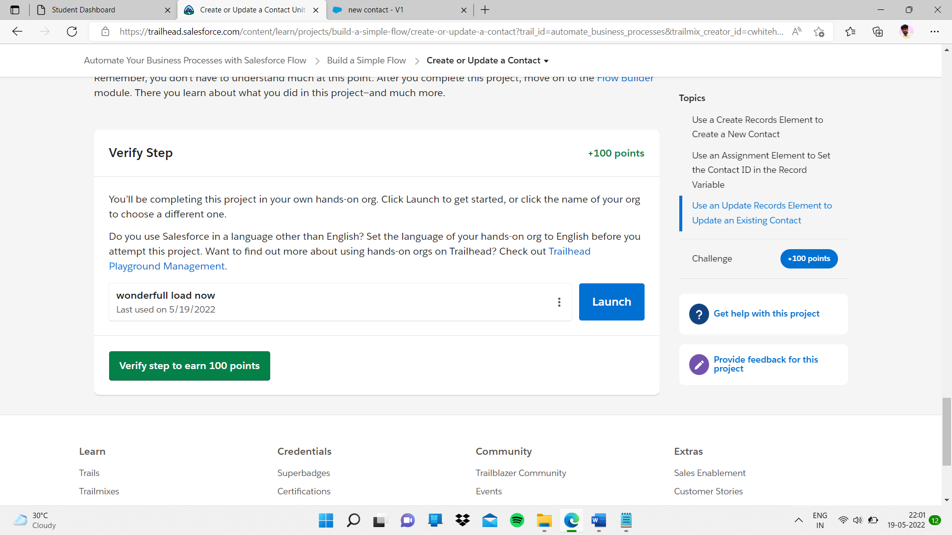

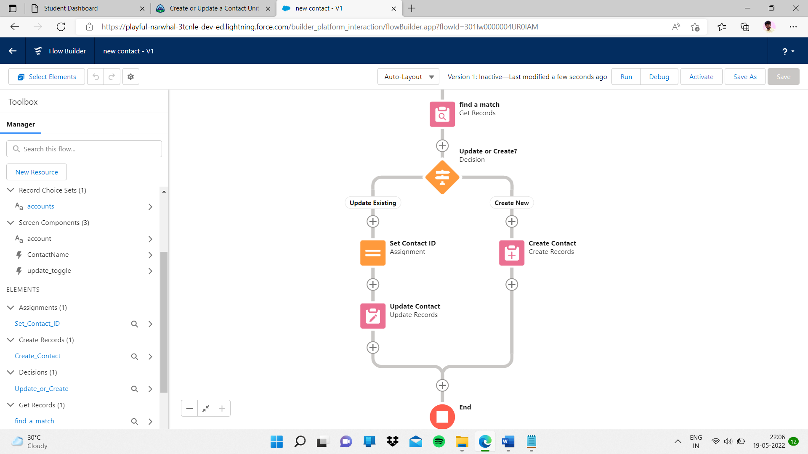

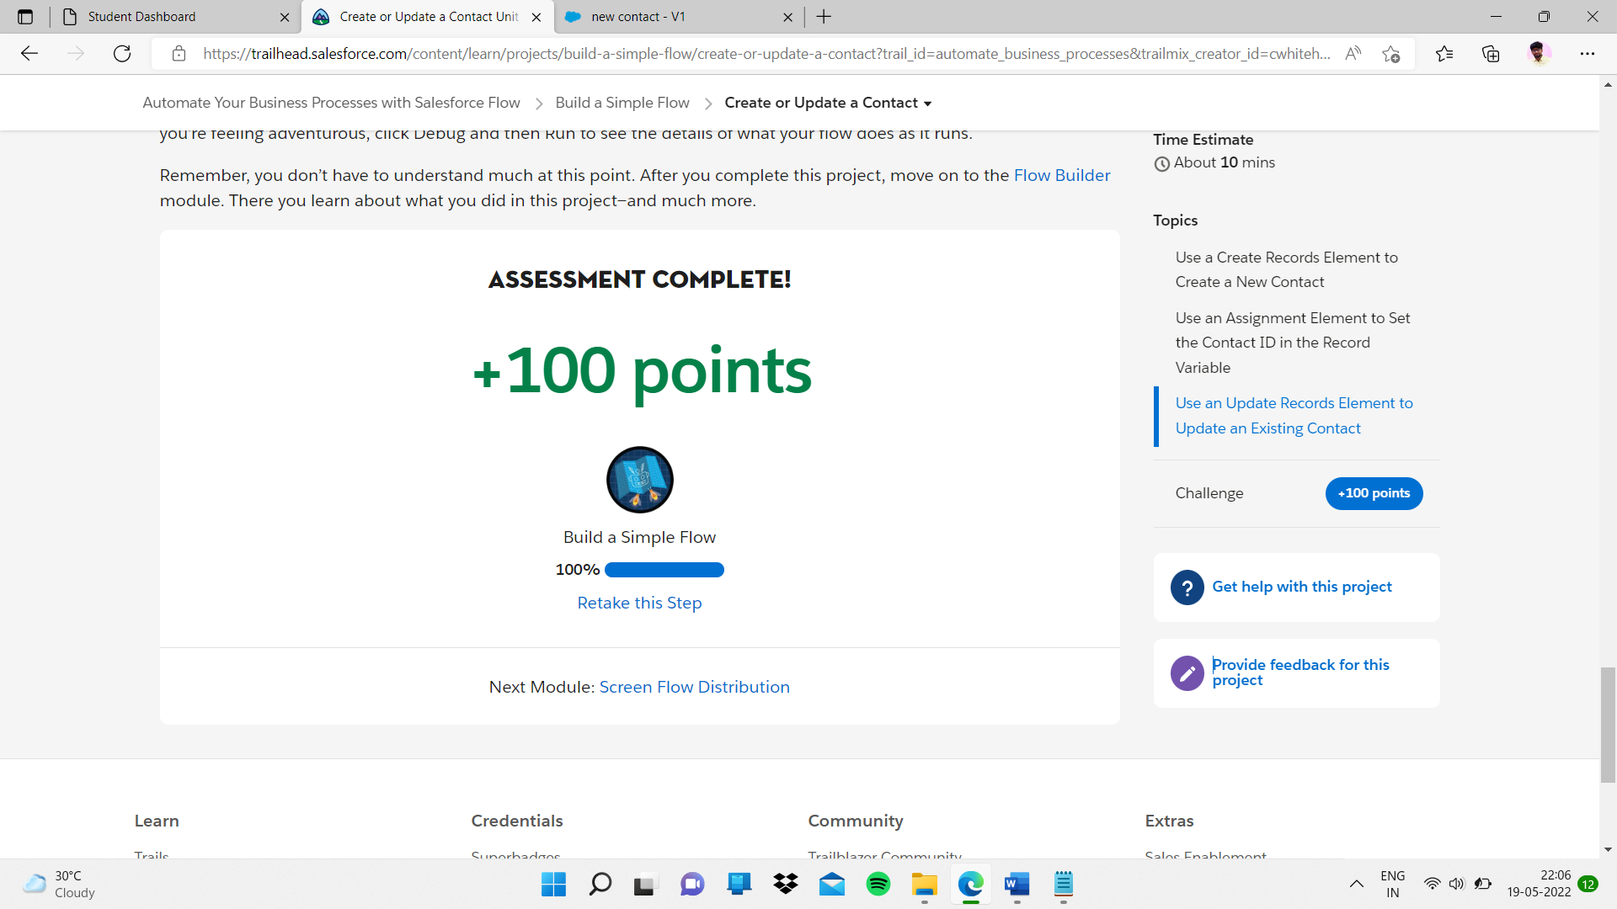

Sub heading:- Screen Flow Distribution

Sub topic:- Get Started with Flow Distribution

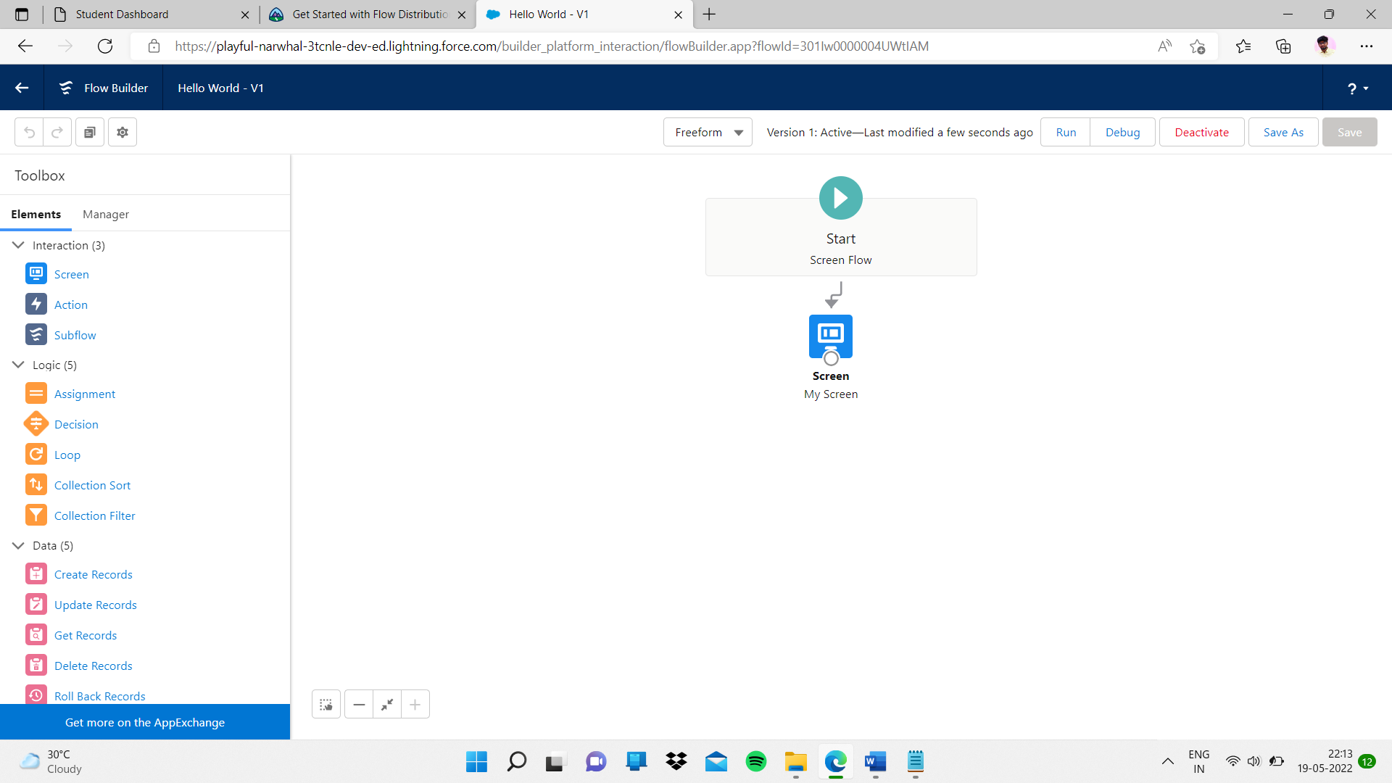

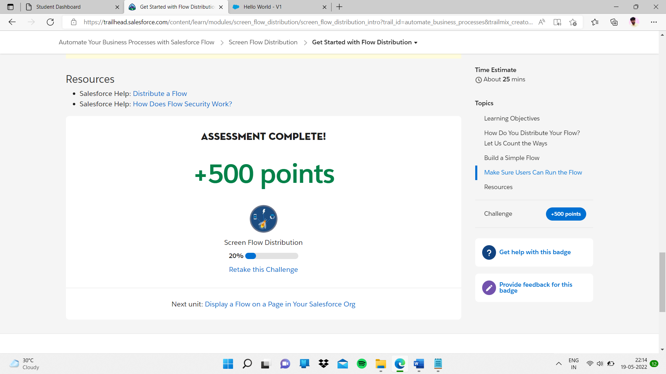

Sub topic:- Display a Flow on a Page in Your Salesforce Org

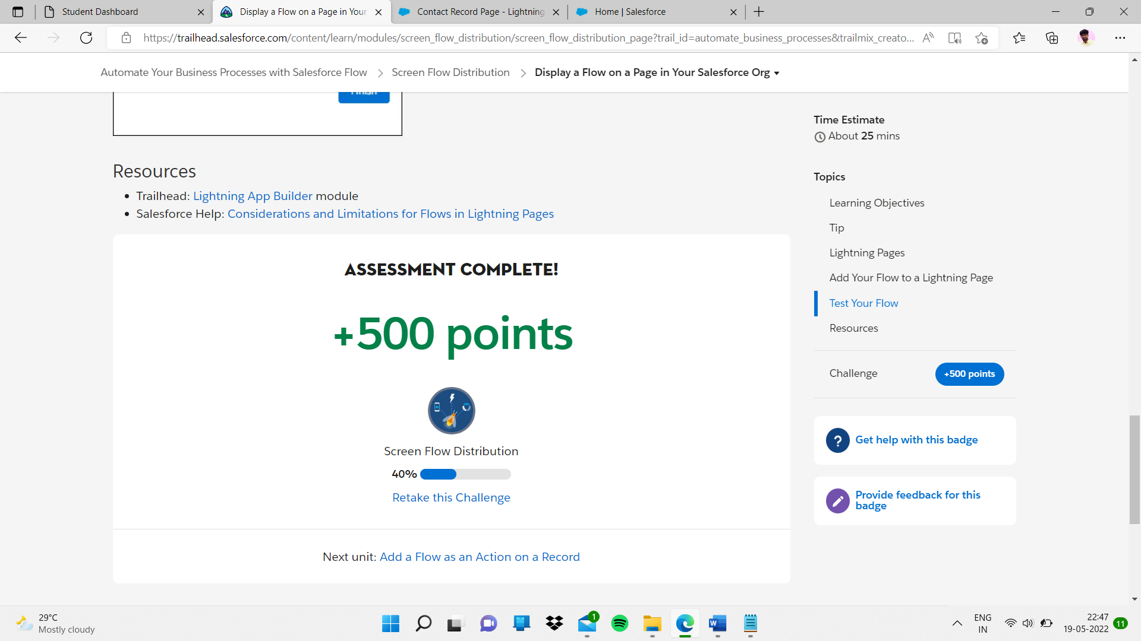

Sub topic:- Add a Flow as an Action on a Record

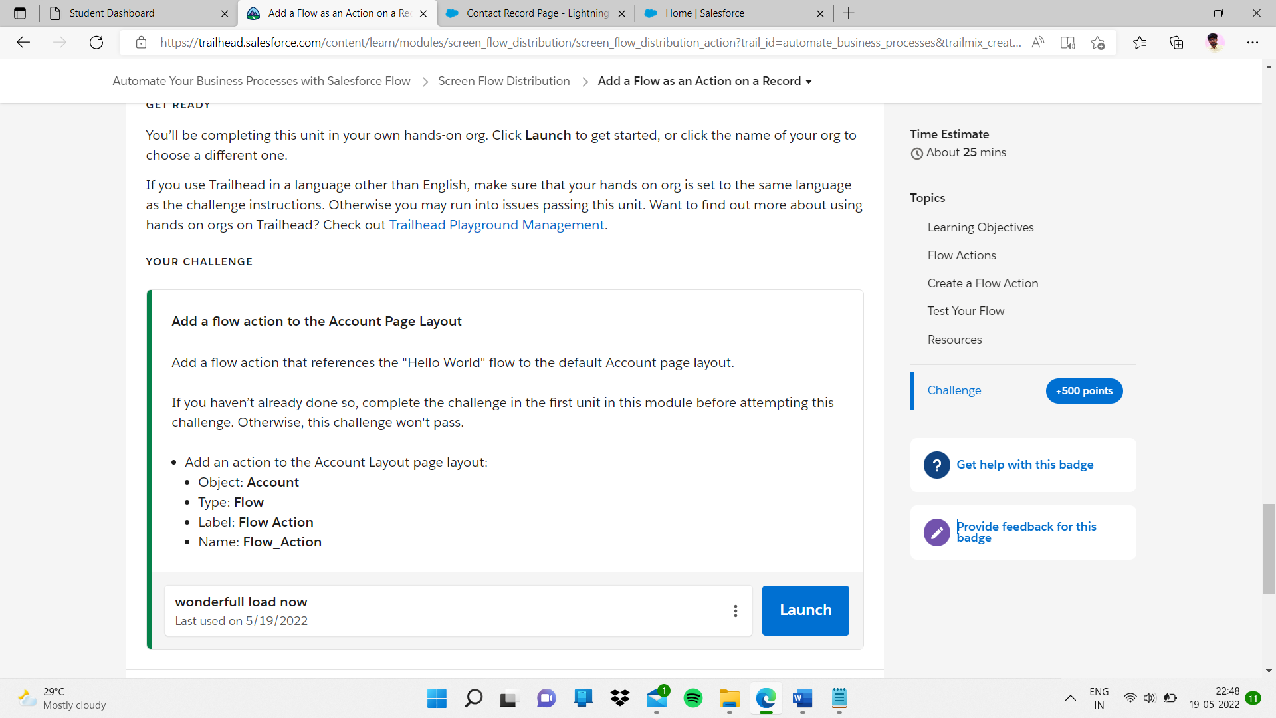\

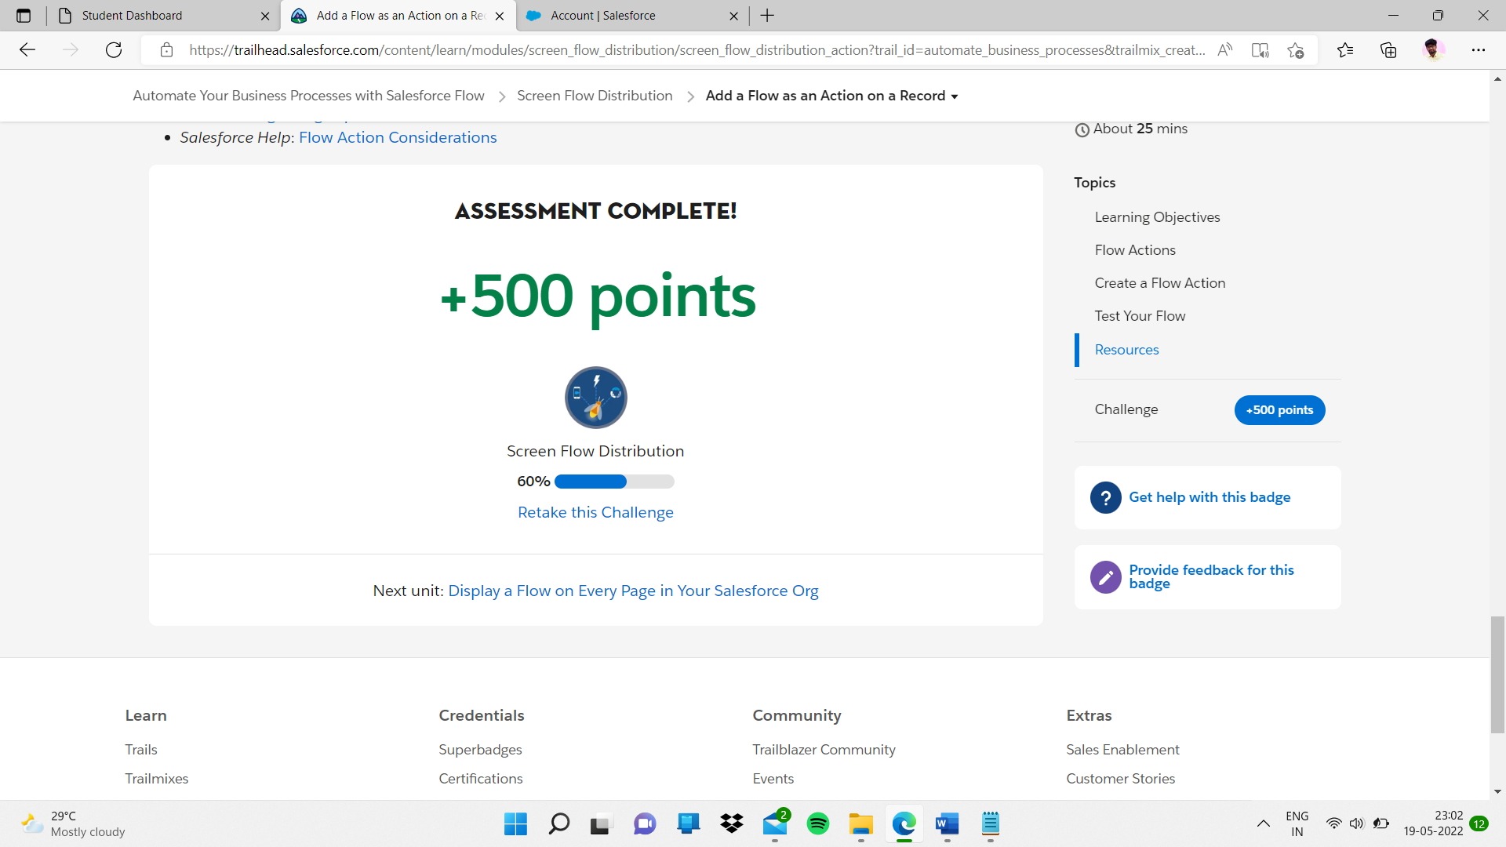

Sub topic:-

Display a Flow on Every Page in Your Salesforce Org

Completed

Sub topic:-

# **Display a Flow on a Page Outside Your Salesforce Org**

Completed

# **Display a Flow on a Page Outside Your Salesforce Org**

# Build a Discount Calculator

# **Prepare Your Org**

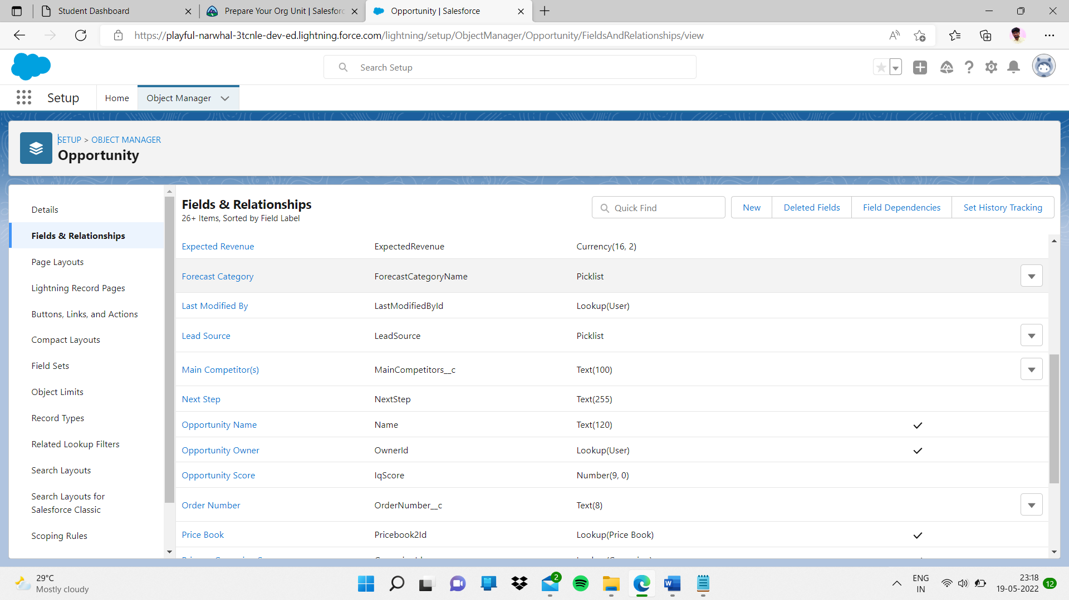

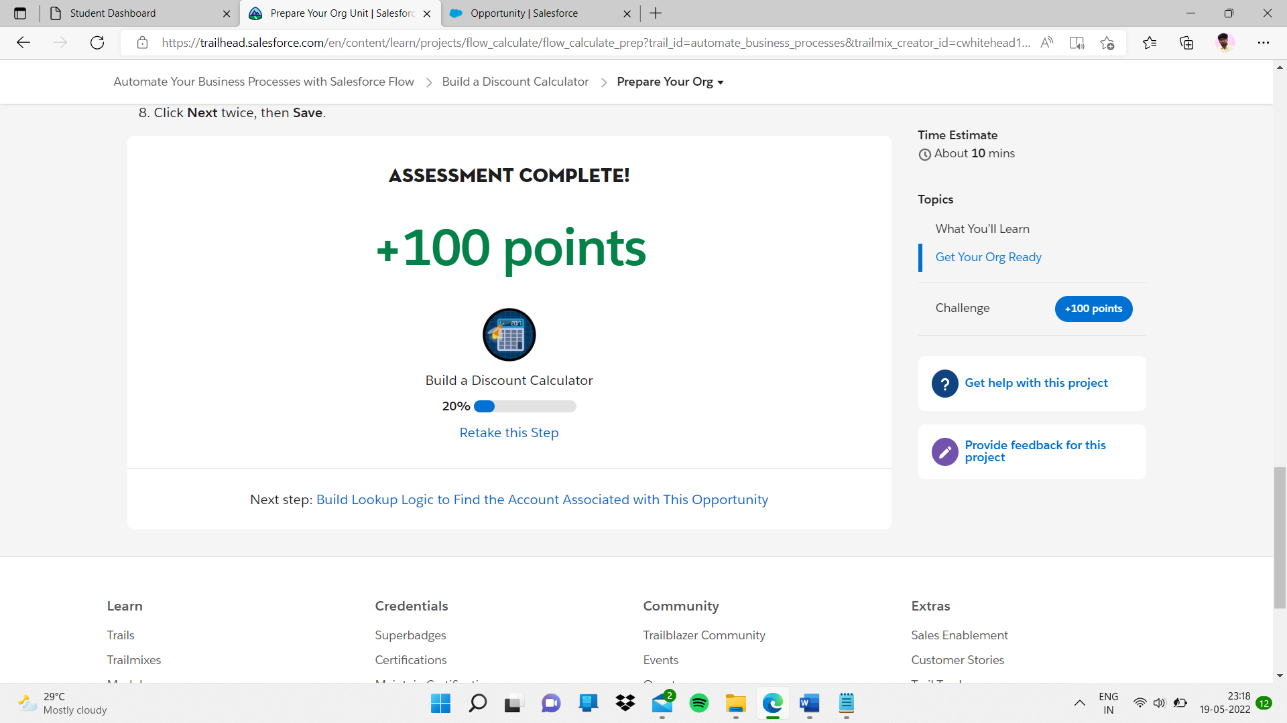

Sub topic:-

Add a Flow as an Action on a RecordBuild Lookup Logic to Find the Account Associated with This Opportunity

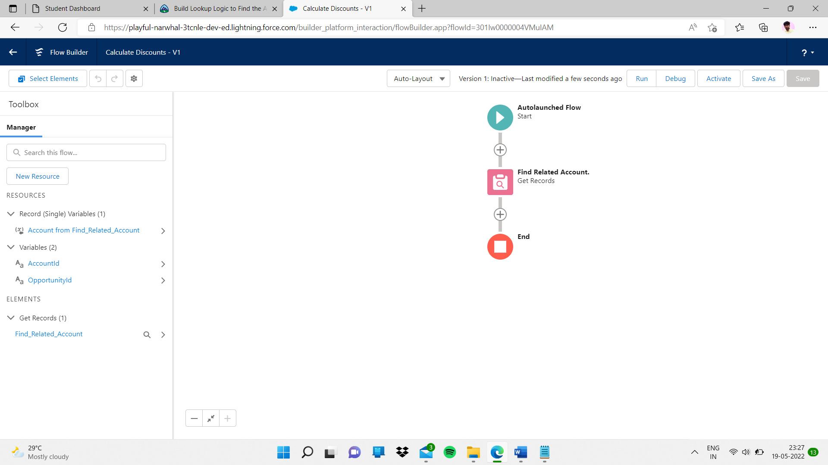

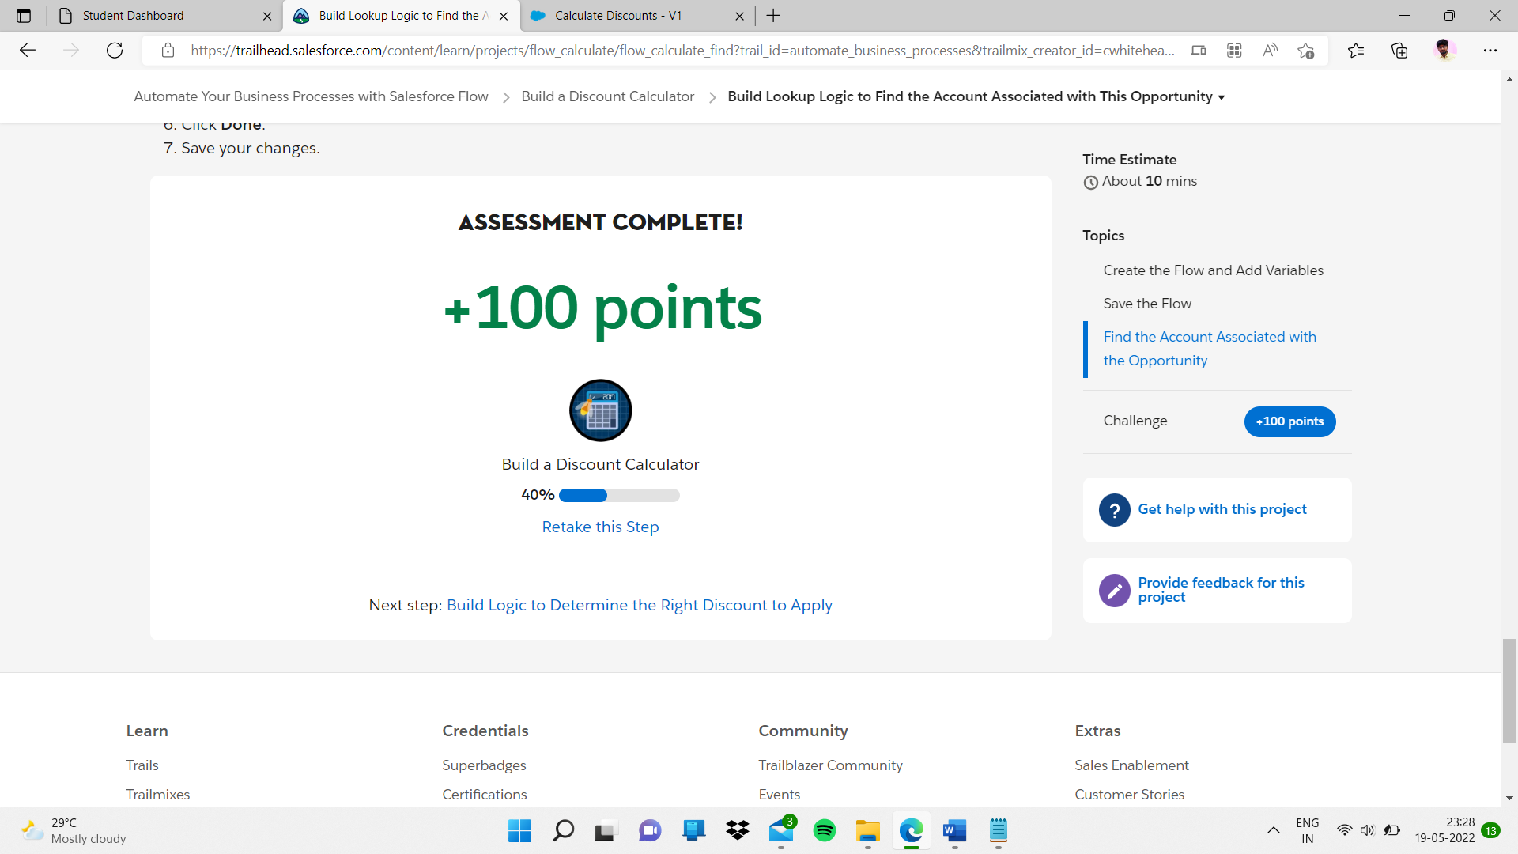

Sub topic:-

# **Build Logic to Determine the Right Discount to Apply**

